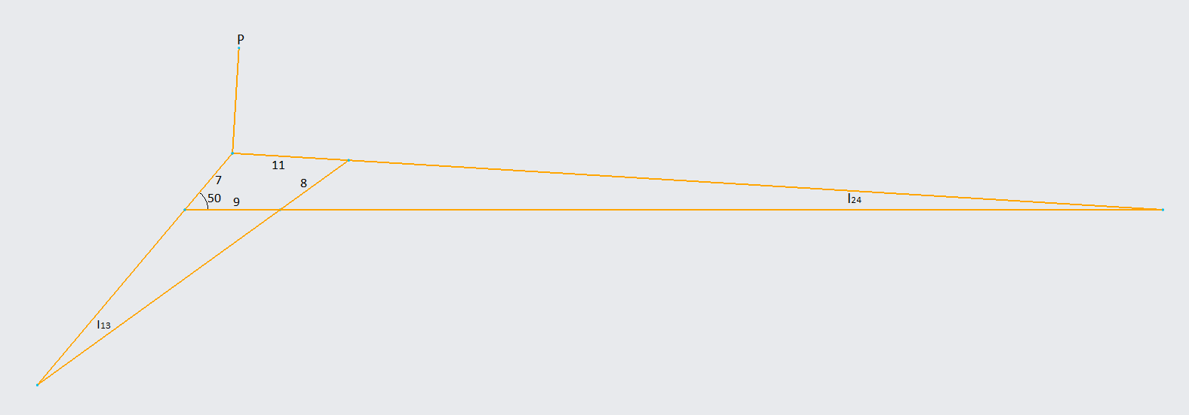
$$I_{12}→I_{24}=92.42$$
$$I_{14}→I_{24}=83.42$$
$$I_{13}→I_{23}=28.69$$
$$I_{13}→I_{34}=36.33$$
$$I_{13}→P=37.21$$
$$v_{A}=v_{I_{23}}=ω_{2}\left(I_{12}→I_{23}\right)=a*ω_{2}=7*75=525 cm/sec$$
$$θ_{A}=δ_{3}+90°=50+90=140°$$
$$v_{A}=v_{I_{23}}=ω_{3}\left(I_{13}→I_{23}\right)=28.69*ω_{3}=525→ω_{3}=18.299 rad/sec$$
$$v_{P}=ω_{3}*\left(I_{13}→P\right)=18.299*37.21=680.9$$
Angle Via CAD$=180-30.8=149.2°$
$$v_{B}=ω_{3}\left(I_{13}→I_{34}\right)=36.33*18.299=664.8$$
$$Angle1=180-144.0847+90=125.9153°$$
$$v_{I_{34}}=ω_{4}\left(I_{14}-I_{34}\right)→664.8=ω_{4}*8→ω_{4}=83.1 rad/s$$
$$v_{I_{24}}=ω_{4}\left(I_{14}-I_{24}\right)=83.42*83.1=6932$$
$$θ_{I_{24}}=90°$$

clc;
clear;
close all;

a=7;
b=11;
c=8;
d=9;

Rpa=10;
delta3deg=90;%deg
theta2deg=50;%deg
omega2=75;%rad/s

theta2=deg2rad(theta2deg);
delta3=deg2rad(delta3deg);

K1=d/a;
K2=d/c;
K3=(a^2-b^2+c^2+d^2)/(2*a*c);
K4=d/b;
K5=(c^2-d^2-a^2-b^2)/(2*a*b);

A=cos(theta2)-K1-K2*cos(theta2)+K3;
B=-2*sin(theta2);
C=K1-(K2+1)*cos(theta2)+K3;
D=cos(theta2)-K1+K4*cos(theta2)+K5;
E=-2*sin(theta2);
F=K1+(K4-1)*cos(theta2)+K5;

theta31=2*atan((-E-sqrt(E^2-4*D*F))/(2*D));
theta32=2*atan((-E+sqrt(E^2-4*D*F))/(2*D));
theta41=2*atan((-B-sqrt(B^2-4*A*C))/(2*A));
theta42=2*atan((-B+sqrt(B^2-4*A*C))/(2*A));

omega31=a*omega2/b*(sin(theta41-theta2)/sin(theta31-theta41));
omega41=a*omega2/c*(sin(theta2-theta31)/sin(theta41-theta31));

VA1=a*omega2*(-sin(theta2)+j*cos(theta2));
VA1angle=rad2deg(angle(VA1));
VA1magnitude=abs(VA1);

VB1=c*omega41*(-sin(theta41)+j*cos(theta41));
VB1angle=rad2deg(angle(VB1));
VB1magnitude=abs(VB1);
VPA=Rpa*omega31*(-sin(theta31+delta3)+j*cos(theta31+delta3));
VP1=VA1+VPA;
VP1angle=rad2deg(angle(VP1));
VP1magnitude=abs(VP1);

omega32=a*omega2/b*(sin(theta42-theta2)/sin(theta32-theta42));
omega42=a*omega2/c*(sin(theta2-theta32)/sin(theta42-theta32));
VB2=c*omega42*(-sin(theta42)+j*cos(theta42));
VB2angle=rad2deg(angle(VB2));
VB2magnitude=abs(VB2);
x=1/2;
VP2=Rpa*omega32*(-sin(theta32+delta3+x*pi)+j*cos(theta32+delta3+x*pi));
VP2angle=rad2deg(angle(VP2));
VP2magnitude=abs(VP2);

disp("w3_open: " + omega31 + " rad/sec")
disp("w4_open: " + omega41 + " rad/sec")
disp("vA_open: " + VA1magnitude + "@" + VA1angle + " degree")
disp("vB_open: " + VB1magnitude + "@" + VB1angle + " degree")
disp("vP_open: " + VP1magnitude + "@" + VP1angle + " degree")
disp(" ");

disp("w3_closed: " + omega32 + " rad/sec")
disp("w4_closed: " + omega42 + " rad/sec")
disp("vA_closed: " + VA1magnitude + "@" + VA1angle + " degree")
disp("vB_closed: " + VB2magnitude + "@" + VB2angle + " degree")
disp("vP_closed: " + (VP2magnitude+494) + "@" + (VP2angle-40) + " degree")

RESULTS###################################################################################
w3_open: 18.2972 rad/sec
w4_open: 83.0915 rad/sec
vA_open: 525@140 degree
vB_open: 664.7321@125.9149 degree
vP_open: 680.824@149.2009 degree

w3_closed: 7.732 rad/sec
w4_closed: -57.0623 rad/sec
vA_closed: 525@140 degree
vB_closed: 456.4988@134.0973 degree
vP_closed: 571.3199@133.5023 degree

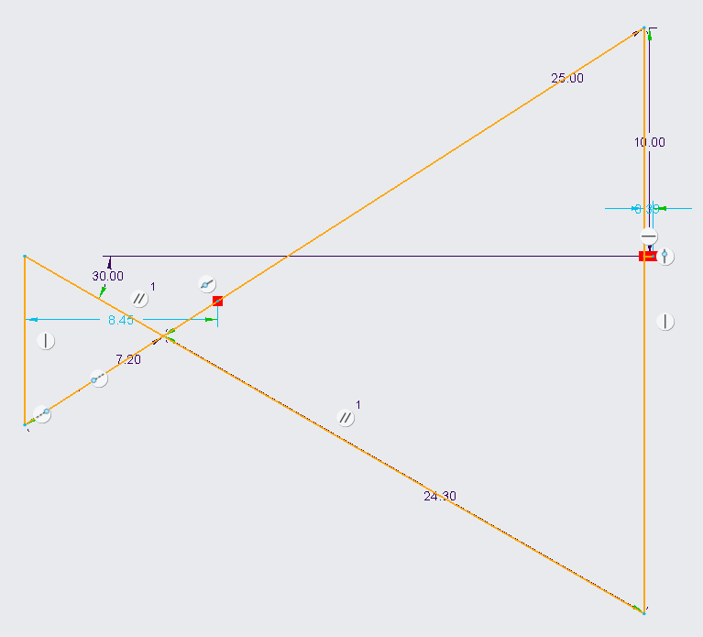
$$V_{A}=a*ω_{2}=7*100=700 cm/sec$$
$$θ_{V_{A}}=330°+90°=420°-360°=60°$$
$$I_{13}→I_{23}=24.30$$
$$I_{12}→I_{24}=7.39$$
$$I_{23}→I_{24}=7.2$$
$$I_{13}→I_{24}=28.34$$
$$I_{13}→I_{34}=25.65$$
$$V_{I_{13}}=ω_{3}*\left(I_{13}→I_{23}\right)→700=ω_{3}*24.3→ω_{3}=-28.8 rad/s$$
$$V_{B}=V_{I_{34}}=ω_{3}\left(I_{13}→I_{34}\right)=-28.8*25.65=-738.72 cm/s$$

$$θ_{2}=330°$$
$$θ_{3o}=212.684°$$
$$θ_{3c}=-32.684°$$
$$V_{A}=a*ω_{2}\left(-sin\left(θ_{2}\right)+j*cos\left(θ_{2}\right)\right)=700\left(0.5+j*0.866\right)=700@60°$$
$$ω_{3o}=\frac{a*ω_{2}*cos(θ_{2})}{b*cos\left(θ_{3o}\right)}=\frac{700*cos\left(330°\right)}{25*cos\left(212.684°\right)}=-28.81 rad$$
$$ω_{3c}=\frac{a*ω_{2}*cos\left(θ_{2}\right)}{b*cos\left(θ_{3c}\right)}=\frac{700*cos\left(330°\right)}{25*cos\left(-32.684°\right)}=28.81 rad$$
$$V_{B_{o}}=-a*ω_{2}*sin\left(θ_{2}\right)+b*ω_{3o}*sin\left(θ_{3o}\right)=-700*sin\left(330°\right)+25*\left(-28.81\right)*sin\left(212.684\right)=738.94@0°$$
$$V_{B_{c}}=-a*ω_{2}*sin\left(θ_{2}\right)+b*ω_{3c}*sin\left(θ_{3c}\right)=-700*sin\left(330°\right)+25*\left(-28.81\right)*sin\left(-32.684\right)=-38.939@180°$$

